ProjectMakers  
AutoSave Editor

27.05.2018

## Project background

Nothing is more important than regular storage.  
 But it quickly happens that you forgot it before the test  
 to save the scene.  
 To avoid this, there is now the AutoSave Editor.

## Scope of the project

The asset consists of the C# script and 9 textures.  
Tested with Unity 5.2 to 2019.2

## Description

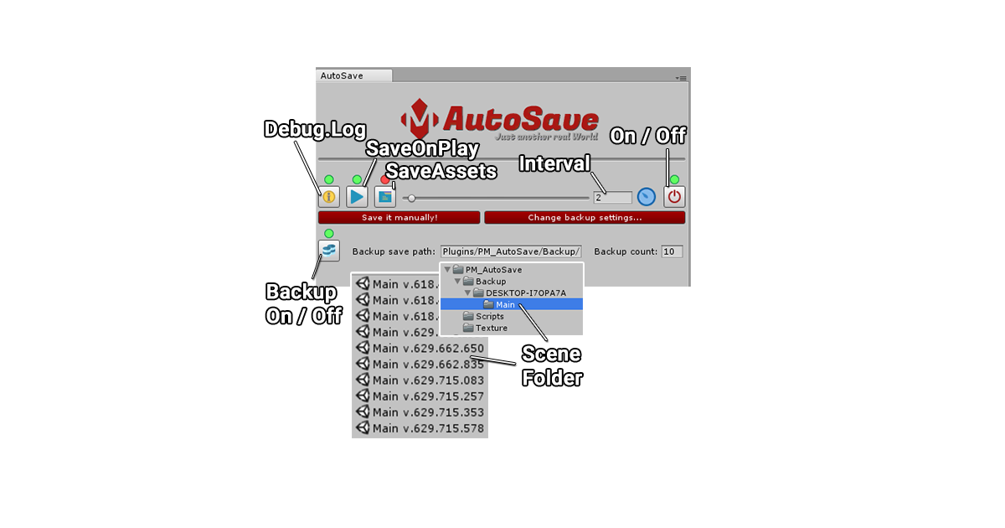

**Debug.Log – Displays all actions performed by this asset in Debog.Log.**

**Save on play – Saves when the playbuttons are activated.**

**Save Assets – Save Assets.**

**Save interval – Specifies how many minutes (1 - 30) will be stored.**

**On/Off – Switches the Autosave function on or off.**

**Backup On/Off – Switches the Backup function on or off.**

* **Scene Folder – A folder is created with the host name and the name of the scene,**

**in this the respective scenes are stored.**

**Version – The displayed version is the time in „ticks“: 636 629.662.835 123456**

http://projectmakers.de